**PROJECT COVER**

|  |  |
| --- | --- |
|  | **LDCW6123 FUNDAMENTALS OF DIGITAL COMPETENCE FOR PROGRAMMERS**  **Trimester 2, 2023/2024** |

**GROUP PROJECT**

Lecturer: CHRISTOPHER

**Group: ___________**

***Prepared by:***

|  |  |  |
| --- | --- | --- |
| **Student ID** | **Student name** | **Phone number** |
| **242UC2431U** | **DARCHANAA MARAN A/L SUGUMARAN** | **60167271475** |
| **242UC241FG** | **AYANLE SULEIMAN JAMA** | **60183707795** |
| **242UC241GB** | **Sivananthan Lee A/L Jayapalan** | **60126258472** |
| **242UC242WF** | **Methum Ransidu Arachchi Pathirana** | **60182979375** |
| **242UC2431D** | **SALAHELDIN ELDIRDIRI BADR OSMAN** | **601112436529** |

**Declaration by group leader**

**I hereby declare that all group members’ names are correctly included in the above section. I hold a copy of this assignment, which I can produce if the original is lost or damaged. I certify that no part of this assignment has been copied from any other student’s work or from any other source except where due acknowledgement is made in the assignment.**

**Group leader’s signature : **

**Group leader’s name :** DARCHANAA MARAN A/L SUGUMARAN

**Group leader’s student ID : 242UC2431U**

**Date : 4/10/2024**

**CONTENTS PAGE NO.**

1. **WEBSITE URL LINK:**

[**https://brave-onion-lk0bpq.mystrikingly.com**](https://brave-onion-lk0bpq.mystrikingly.com)

1. **MOBILE APPS URL LINK:** [**https://www.figma.com/proto/SYvXW05DjxPi8jmoyix51P/Happy-Tails-Haven-App?node-id=3-37&node-type=canvas&t=4EdELdeJGsCvHp4x-0&scaling=scale-down&content-scaling=fixed&page-id=0%3A1**](https://www.figma.com/proto/SYvXW05DjxPi8jmoyix51P/Happy-Tails-Haven-App?node-id=3-37&node-type=canvas&t=4EdELdeJGsCvHp4x-0&scaling=scale-down&content-scaling=fixed&page-id=0%3A1)
2. **GITHUB LINK:** [**https://github.com/TheSealOfLife/Group_Assignment/tree/Documentation**](https://github.com/TheSealOfLife/Group_Assignment/tree/Documentation)
3. **MOBILE APP USER MANUAL:**
   1. **INTRODUCTION Page 3**
   2. **NAVIGATION GUIDE Page 3-5**
   3. **DASHBOARD OVERVIEW & FUNCTIONALITY GUIDE Page 6-17**
4. **VISUAL DESIGN AND BRANDING Page 18**

**Introduction of the project**

This user manual aims to comprehensively discuss and outline the expected uses and the way the mobile application is constructed. The application is expected to assist people in performing and monitoring their activities effectively, providing tools and elements that help in simplifying everyday functions and enhancing the productivity of the user. This application, however, enables the users to have beneficial information on hand, perform several functions, and keep track of their work progress. The main aim of this application is to demonstrate the service of the Happy Tail Haven organisation, which focusses on pet adoption and rescue. It connects the potential adopters, pet lovers, and volunteers to their desired pet and rescues the pet. The app showcases the listing of adoptable pets with detailed information and photos. Moreover, facilitate the foster care programs for the pet.

**Navigation Guide for Happy Tails Haven App**

**1. Home Screen (Welcome Page)**

Purpose: Introduces users to the app, with a focus on helping cats and dogs find homes.

Main Action: Users can Sign Up for a new account or Log In to an existing account.

**2. Login Screen**

*Purpose:*

* For users to log in with their credentials.

*Main Action:*

* Enter email and password, then click Login.

*Option:*

* Forgot Password? for recovering login details.

**3. Sign Up Screen**

*Purpose:*

* To create a new account.

*Main Action:*

* Users enter their full name, email, password, and confirm password, then click Sign Up.

**4. Main Content Screen (After Login)**

*Tabs:*

* Mixed: Shows both cats and dogs available for adoption.
* Cats: Displays only cat profiles.
* Dogs: Displays only dog profiles.
* Favourites: Shows animals the user has favourited.

*Animal Profiles:*

* Each profile includes Location, Description, and Posted By information.
* The Star Icon allows users to favourite an animal.
* The Heart Icon indicates whether the pet is neutered (filled heart means neutered).

**5. Navigation at the Bottom**

* A button for Pets that redirects users to a broader list of animals for adoption.
* A button for Blogs that redirects users to a blogspot page where users can see blogs related to pets
* A button for Events that redirects users to view and join events hosted by Happy Tails Haven
* A button for Donate that redirects users to the donation page of the app allowing them to donate to fundraisers used by the organization
* A button for FAQ that redirects users to the frequently asked questions for doubts the users may have regarding adoption.

**Main Sections:**

* Search: Located at the top, allows you to search for specific events or content.
* Featured Events: Highlights upcoming events, including "Happy Tails Haven Fundraiser" and "Glass box Tamarind Square Cyberjaya."
* Explore: Provides links to various categories of events, such as "Fundraising," "Volunteering," and "Pet Training."
* Events Schedule: Shows a calendar view of upcoming events, organized by month.
* Footer: Contains links to "Pets," "Blogs," "Events," "Donate," and "Profile."
* Navigation Elements:
* "View" and "Join" buttons: Found next to featured events, allowing you to view more details or join the event.
* "View All" link: Located under the "Explore" section, lets you see a complete list of events in each category.
* Month navigation arrows: In the "Events Schedule," these arrows allow you to navigate between different months.

**HAPPY TAILS HAVEN APP USER GUIDE**

LOGIN BUTTON FOR EXISTING USERS TO LOGIN INTO A NEW DEVICE WITH THE SAME ACCOUNT

SIGN UP BUTTON FOR NEW USER SO THEY COULD REGISTER A NEW ACCOUNT

**HOMEPAGE**

KEY IN YOUR PASSWORD OF YOUR ACCOUNT

WHEN FORGETTEN YOUR PASSWORD, PRESS THIS TO RECEIVE A ONE TIME PIN

INSERT EMAIL ADDRESS OF YOUR ACCOUNT

PRESS BUTTON TO LOGIN

**LOG IN PAGE**

LIST IN YOUR EMAIL

RE-TYPE YOUR PASSWORD TO CONFIRM IT

INSERT YOUR DISPLAY NAME

LIST IN YOUR DESIRED PASSWORD

PRESS THIS BUTTON TO SIGN UP FOR A NEW ACCOUNT

**SIGN UP PAGE**

SORT BY THE GIVEN FILTERS SUCH AS LATEST AND NEAREST

ADD TO FAVOURITES BUTTON ALLOWS YOU TO BOOKMARK PETS TO VIEW LATER

OPEN OF CLOSES THE NOTIFICATION FOR NEW UPDATES OR REMINDERS

CHOOSE YOUR DESIRED FEED BY SELECTING THE TYPE OF ANIMALS YOU WANT

ABLE TO SEARCH WITH SOME KEYWORDS



**PET ADOPTION PAGE**

COULD BE USED TO PERSONALISE THE USER’S PROFILE

COULD HELP USERS MANAGE THE NOTIFICATION SETTINGS

COULD HELP GET IN CONTACT WITH THE HELP DESK

SHOWS THE USERS NAME AND PROFILE PIC

SHOWS THE COMPANY’S MOTIVE AND HISTORY

GOES TO SETTINGS SO THE USERS COULD SET THE APP TO THEIR LIKING

LOGS OUT THE ACCOUNT FROM THE DEVICE

**DROP-DOWN MENU**

SHWS BUTTONS TO QUICKLY GO BETWEEN PAGES

BLOGS WHICH SHOW THE SUMMARY AND USER WHO POSTED IT, WHILE ALSO GIVING AN OPTION TO SAVE AND SHARE THE BLOG

**BLOGSPOT PAGE**

THE EXPLORE PAGE ALLOWS US TO DISCOVER NEW EVENTS BASED ON OUR PREFERENCES WITH THE VIEW ALL BUTTON ABLE TO SHOW ALL THE EVENTS AVAILABLE



ALLOWS THE USER TO EITHER VIEW THE JOB AND SEE ITS DETAILS AND JOIN THE EVENTS



ALLOWS TO SEARCH EVENTS WHILE ALSO FILTERING IT ACCORDING TO THE PREFERENCE

**EVENTS PAGE**

SEARCH UP VARIOUS DONATIONS

SHARE BUTTON TO SHARE THE LINK OF DONATION TO OTHER PEOPLE

SHOWS THE DONATION NAME AND DETAILS SUCH AS HOW MUCH MONEY IS COLLECTED

**DONATION PAGE**

THE BUTTON IS FOR USERS TO CONFIRM THE FUND THEYRE DONATING TO AND BRINGS THEM TO ANOTHER PAGE

**DONATION PAGE**

ALLOWS THE USER TO CHOOSE THE DONATION AMOUNT WHICH THEY PREFER WHETHER IT’S A PRESET OR YOUR PERSONALISED ONE AND ALLOW THEM VARIOUS PAYMENT METHODS

KEY IN YOUR DESIRED AMOUNT FOR DONATION

**DONATION PAGE**

LIVE CHAT BUTTON TO TALK WITH AN AGENT TO GET MORE INFORMATION ABOUT ANY QUESTIONS THEY USERS MAY HAVE

SHOWS THE MOST ASKED QUESTIONS SO USER COULD GET A QUICK ANSWER

ALLOWS THE USER TO SEARCH FREQUENTLY ASK QUESTIONS

**FAQ PAGE**

**Visual Design & Branding:**

Multiple choice of visual designs was incorporated into building the and the website for the Happy Tails Haven blog. Distinct colors were used in building the website. Warm colors like light blue and deep pink were used to include more inviting vibe for the website visitors. The mobile application design is heavily inspired by the foundation of the website. Furthermore, the mobile application is split into four different tabs.

The pages consist of “Pets,” “Blogs,” “Event,” “Donate” and “FAQ” Users can easily change taps at the click of a button and navigate through the app functions. On top of that, our logo design includes an owner with his pet under a roof. This logo aims to signify the positivity of adopting a creature into your home. We wish to give our users motivation and a chance to change the trajectory of the animals that were left in the shelter with no destined home.

The color scheme selected of the mobile application also includes a splash of green for the donation tab. This is because green is a universal color scheme for currency and money. So, the selection of green signifies a tab specifically for user donation that will be directed to building more and maintain existing facilities for the well-being of the animals present at the shelter.

**Group member declaration**

*(Each group member, including the* ***group leader****, must individually fill up and submit this form)*

Group member’s name : Methum Ransidu Arachchi Pathirana

For the purpose of completing this assignment, I have performed the following tasks (please list):

* I utilized strikingly.com to create a semi-functional website for Happy Tails Haven, a pet shelter organization.
* Alongside the website, I also designed the Happy Tails Haven app using Figma.

*I hereby declare that I have assessed this submission and I take full responsibility should there be any inaccuracies, incompleteness, omissions, delays or non-submission.*

|  |  |
| --- | --- |
| Group member’s signature |  |
| Group member’s name | : Methum Ransidu Arachchi Pathirana |
| Group member’s ID | : 242UC242WF |
| Group member’s tel. no. | : 60182979375 |
| Group member’s email | : ARACHCHI.PATHIRANA.METHUM@ student.mmu.edu.my |
| Date | : 04/10/2024 |

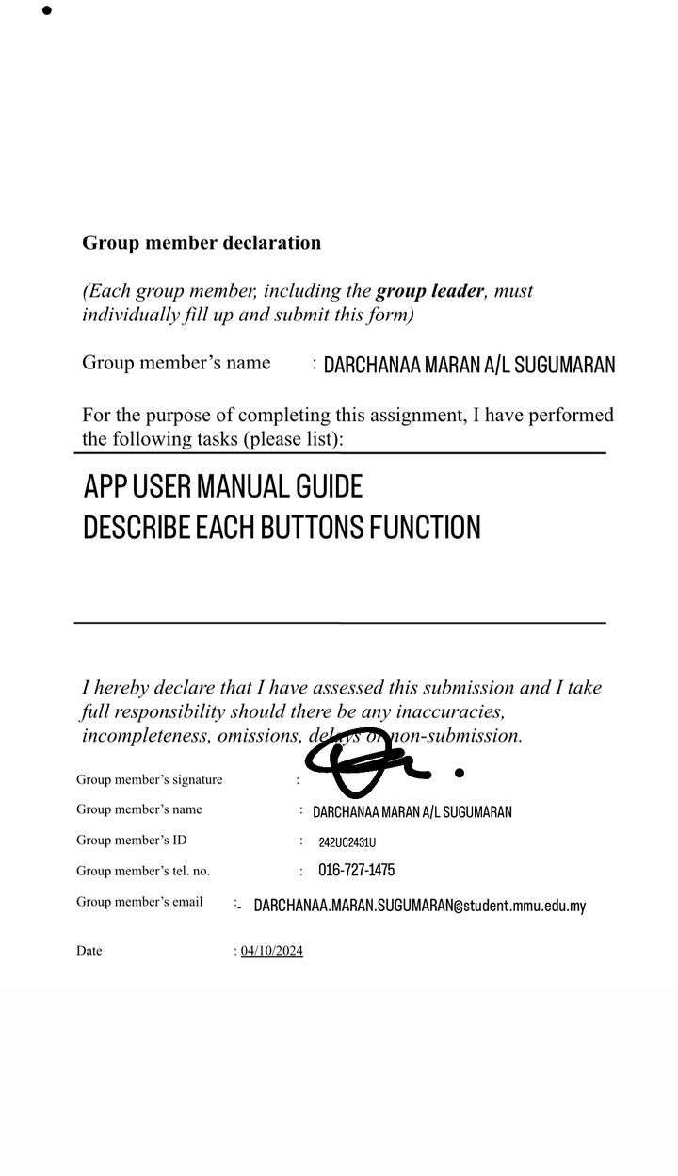

**Group member declaration**

*(Each group member, including the* ***group leader****, must individually fill up and submit this form)*

Group member’s name : SALAHELDIN ELDIRDIRI BADR OSMAN

For the purpose of completing this assignment, I have performed the following tasks (please list):

* I made the Navigation Guide

*I hereby declare that I have assessed this submission and I take full responsibility should there be any inaccuracies, incompleteness, omissions, delays or non-submission.*

|  |  |
| --- | --- |
| Group member’s signature |  |
| Group member’s name | : SALAHELDIN ELDIRDIRI BADR OSMAN |
| Group member’s ID | : 242UC2431D |
| Group member’s tel. no. | : 60 11-1243 6529 |
| Group member’s email | : SALAHELDIN.ELDIRDIRI.BADR@student.mmu.edu.my |
| Date | : 04/10/2024 |

**Group member declaration**

*(Each group member, including the* ***group leader****, must individually fill up and submit this form)*

Group member’s name : AYANLE SULEIMAN JAMA

For the purpose of completing this assignment, I have performed the following tasks (please list):

I have prepared the following tasks:

1. Provided brief overview of purpose the website and functionality
2. Addressed the target audience of the manual.

*I hereby declare that I have assessed this submission, and I take full responsibility should there be any inaccuracies, incompleteness, omissions, delays or non-submission.*

Group member’s name : AYANLE SULEIMAN JAMA

Group member’s ID : 242UC241FG

Group member’s tel. no. : +60183707795

Group member’s email : ayaanlesaleeban08@gmail.com

Date : 4/10/2024